# Healthcare Patient Analytics & ETL Star Schema Report

-- Sayan Das

## 1. Generating and Loading CSV Data

I started by generating synthetic data for six main entities:  
- **Patients** (patient demographics)  
- **Doctors** (doctor details)  
- **Admissions** (patient admissions)  
- **Vitals** (patient vitals during hospital stays)  
- **Treatments** (treatments and medications)  
- **Readmission_Risk** (predicted readmission risk)

To ensure adequate variety, I created **at least 10 rows** per table. For example, in the **Patients** table, I randomly generated first names, last names, dates of birth, and phone numbers. In the **Doctors** table, I randomly generated specialties and contact numbers. Here is a **Python code snippet** showing how I generated some of the sample data:

import names

def random_date(start_year=2020, end_year=2025):  
 """Generate a random date between start_year and end_year."""  
 start_date = datetime(start_year, 1, 1)  
 end_date = datetime(end_year, 12, 31)  
 delta = end_date - start_date  
 random_days = random.randrange(delta.days)  
 return start_date + timedelta(days=random_days)  
  
def random_phone():  
 """Generate a random 10-digit phone number as a string."""  
 return str(random.randint(10**9, 10**10 - 1))  
  
def random_diagnosis():  
 return random.choice(["Pneumonia", "Hypertension", "Asthma Attack", "Diabetes Complications", "Heart Failure", "Sepsis", "Kidney Stones", "Migraine", "COVID-19", "Fracture"])  
  
def random_specialization():  
 return random.choice(["Cardiologist", "Pulmonologist", "General Physician", "Neurologist", "Orthopedic", "Endocrinologist", "Gastroenterologist"])  
  
def random_chronic_condition():  
 return random.choice(["None", "Hypertension", "Asthma", "Diabetes", "Heart Disease", "None", "None"])  
  
# 1.1 Patients (>= 10 rows)  
num_patients = 10  
patient_ids = list(range(101, 101 + num_patients))  
patients_data = []  
for pid in patient_ids:  
 patients_data.append([  
 pid,  
 names.get_first_name(),  
 names.get_last_name(),  
 random_date(1950, 2000).date(), # dob  
 random.choice(["Male", "Female"]),  
 random_phone(),  
 f"{random.randint(100,999)} Main St",  
 random_chronic_condition()  
 ])  
  
patients_df = pd.DataFrame(patients_data, columns=[  
 "patient_id", "first_name", "last_name", "dob", "gender", "contact_no", "address", "chronic_conditions"  
])  
  
# 1.2 Doctors (>= 10 rows)  
num_doctors = 10  
doctor_ids = list(range(301, 301 + num_doctors))  
doctors_data = []  
for did in doctor_ids:  
 doctors_data.append([  
 did,  
 names.get_first_name(),  
 names.get_last_name(),  
 random_specialization(),  
 random_phone()  
 ])  
  
doctors_df = pd.DataFrame(doctors_data, columns=[  
 "doctor_id", "first_name", "last_name", "specialization", "contact_no"  
])  
  
# 1.3 Admissions (>= 10 rows)  
# We will ensure each admission references an existing patient & doctor  
num_admissions = 10  
admission_ids = list(range(2001, 2001 + num_admissions))  
admissions_data = []  
for aid in admission_ids:  
 patient_id = random.choice(patient_ids)  
 doctor_id = random.choice(doctor_ids)  
 admission_date = random_date(2024, 2025)  
 # Some admissions have not been discharged yet  
 discharge_date = admission_date + timedelta(days=random.randint(1, 10)) if random.random() > 0.3 else None  
 diagnosis = random_diagnosis()  
 room_no = random.choice(["A101","A102","B210","C305","B405","ICU1","ICU2","D110","D120","E201"])  
 admissions_data.append([  
 aid, patient_id, admission_date.date(),  
 discharge_date.date() if discharge_date else None,  
 diagnosis, doctor_id, room_no  
 ])  
  
admissions_df = pd.DataFrame(admissions_data, columns=[  
 "admission_id", "patient_id", "admission_date", "discharge_date",  
 "diagnosis", "doctor_id", "room_no"  
])  
  
# 1.4 Vitals (>= 10 rows)  
# Each vitals row references an existing admission  
num_vitals = 10  
vital_ids = list(range(5001, 5001 + num_vitals))  
vitals_data = []  
for vid in vital_ids:  
 admission_id = random.choice(admission_ids)  
 # Just pick a random time near the admission_date  
 base_date = admissions_df.loc[admissions_df['admission_id'] == admission_id, 'admission_date'].values[0]  
 # Convert base_date to datetime  
 base_datetime = pd.to_datetime(base_date)  
 recorded_time = base_datetime + timedelta(hours=random.randint(0, 100))  
 heart_rate = random.randint(60, 120)  
 bp_systolic = random.randint(100, 160)  
 bp_diastolic = random.randint(70, 100)  
 blood_pressure = f"{bp_systolic}/{bp_diastolic}"  
 oxygen_level = random.randint(88, 100)  
 temperature = round(random.uniform(97.0, 103.0), 1)  
 vitals_data.append([  
 vid, admission_id, recorded_time, heart_rate, blood_pressure, oxygen_level, temperature  
 ])  
  
vitals_df = pd.DataFrame(vitals_data, columns=[  
 "vital_id", "admission_id", "recorded_time", "heart_rate",  
 "blood_pressure", "oxygen_level", "temperature"  
])  
  
# 1.5 Treatments (>= 10 rows)  
num_treatments = 10  
treatment_ids = list(range(7001, 7001 + num_treatments))  
treatments_data = []  
possible_procedures = ["Nebulization", "Blood Pressure Monitoring", "ECG", "X-Ray",   
 "MRI Scan", "IV Fluid Therapy", "Physical Therapy", "Vaccination"]  
possible_meds = ["Amoxicillin 500mg", "Prednisone 10mg", "Metoprolol 50mg", "Ibuprofen 400mg",  
 "Acetaminophen 500mg", "Atorvastatin 20mg", "Insulin 10units"]  
for tid in treatment_ids:  
 admission_id = random.choice(admission_ids)  
 # approximate date of treatment around admission_date  
 base_date = admissions_df.loc[admissions_df['admission_id'] == admission_id, 'admission_date'].values[0]  
 base_datetime = pd.to_datetime(base_date)  
 treat_date = base_datetime + timedelta(days=random.randint(0, 5))  
 procedure = random.choice(possible_procedures)  
 medication = random.choice(possible_meds)  
 dosage = random.choice(["1x daily", "2x daily", "3x daily", "As needed"])  
 treatments_data.append([  
 tid, admission_id, treat_date.date(), procedure, medication, dosage  
 ])  
  
treatments_df = pd.DataFrame(treatments_data, columns=[  
 "treatment_id", "admission_id", "treatment_date", "procedure", "medication", "dosage"  
])  
  
# 1.6 Readmission_Risk (>= 10 rows)  
# We'll keep a 1-to-1 relationship with admissions for demonstration  
risk_ids = list(range(9001, 9001 + num_admissions))  
risk_data = []  
for i, aid in enumerate(admission_ids):  
 pred_date = admissions_df.loc[admissions_df['admission_id'] == aid, 'admission_date'].values[0]  
 pred_date = pd.to_datetime(pred_date) + timedelta(days=random.randint(0,2))  
 risk_score = round(random.uniform(0.2, 0.9), 2)  
 if risk_score < 0.4:  
 risk_level = "Low"  
 elif risk_score < 0.7:  
 risk_level = "Medium"  
 else:  
 risk_level = "High"  
 risk_data.append([  
 risk_ids[i], aid, pred_date.date(), risk_score, risk_level  
 ])  
  
risk_df = pd.DataFrame(risk_data, columns=[  
 "risk_id", "admission_id", "prediction_date", "risk_score", "risk_level"  
])

Each DataFrame was then written out to a CSV file:

patients_df.to_csv("patients.csv", index=False)  
doctors_df.to_csv("doctors.csv", index=False)  
admissions_df.to_csv("admissions.csv", index=False)  
vitals_df.to_csv("vitals.csv", index=False)  
treatments_df.to_csv("treatments.csv", index=False)  
risk_df.to_csv("readmission_risk.csv", index=False)  
  
print("Sample CSV files created with >= 10 rows each.")

## 2. Reading the CSV Files into Pandas

After generating the CSV files, I **extracted** the data into Pandas DataFrames. I used the following code to read each CSV:

patients = pd.read_csv("patients.csv", parse_dates=["dob"])  
doctors = pd.read_csv("doctors.csv")  
admissions = pd.read_csv("admissions.csv", parse_dates=["admission_date", "discharge_date"])  
vitals = pd.read_csv("vitals.csv", parse_dates=["recorded_time"])  
treatments = pd.read_csv("treatments.csv", parse_dates=["treatment_date"])  
readmission_risk = pd.read_csv("readmission_risk.csv", parse_dates=["prediction_date"])

I parsed date columns such as dob, admission_date, discharge_date, and recorded_time to ensure they were stored in proper date/datetime formats.

## 3. Data Cleaning and Quality Checks

### 3.1 Primary Key Uniqueness

I verified that the **primary keys** (e.g., patient_id, doctor_id, admission_id) were unique within their respective DataFrames. If duplicates existed, I dropped them:

def check_and_drop_duplicates(df, pk_col, table_name):  
 dup_count = df.duplicated(subset=[pk_col]).sum()  
 if dup_count > 0:  
 print(f"{table_name}: Dropping {dup_count} duplicate rows based on primary key {pk_col}.")  
 df = df.drop_duplicates(subset=[pk_col])  
 return df  
  
patients = check_and_drop_duplicates(patients, "patient_id", "Patients")  
doctors = check_and_drop_duplicates(doctors, "doctor_id", "Doctors")  
admissions = check_and_drop_duplicates(admissions, "admission_id", "Admissions")  
vitals = check_and_drop_duplicates(vitals, "vital_id", "Vitals")  
treatments = check_and_drop_duplicates(treatments, "treatment_id", "Treatments")  
readmission_risk = check_and_drop_duplicates(readmission_risk, "risk_id", "Readmission_Risk")

### 3.2 Not‐Null Checks

Certain columns, such as first_name, last_name, admission_date, diagnosis, etc., are **NOT NULL** in the conceptual design. I dropped rows that had missing values in these columns:

def drop_missing_required(df, required_cols, table_name):  
 missing_mask = df[required_cols].isnull().any(axis=1)  
 missing_count = missing_mask.sum()  
 if missing_count > 0:  
 print(f"{table_name}: Dropping {missing_count} rows with missing data in required columns {required_cols}.")  
 df = df[~missing_mask]  
 return df  
  
patients = drop_missing_required(patients, ["patient_id", "first_name", "last_name", "dob", "gender", "contact_no"], "Patients")  
doctors = drop_missing_required(doctors, ["doctor_id", "first_name", "last_name", "specialization", "contact_no"], "Doctors")  
admissions = drop_missing_required(admissions, ["admission_id", "patient_id", "admission_date", "diagnosis", "doctor_id"], "Admissions")  
vitals = drop_missing_required(vitals, ["vital_id", "admission_id", "recorded_time", "heart_rate", "blood_pressure", "oxygen_level", "temperature"], "Vitals")  
treatments = drop_missing_required(treatments, ["treatment_id", "admission_id", "treatment_date", "medication"], "Treatments")  
readmission_risk = drop_missing_required(readmission_risk, ["risk_id", "admission_id", "prediction_date", "risk_score", "risk_level"], "Readmission_Risk")

### 3.3 Foreign Key Validation

I also enforced **foreign key constraints** to ensure that, for instance, every admission referenced a valid patient_id and doctor_id. Rows with invalid references were dropped:

# Admissions -> Patients  
invalid_pat_fk = ~admissions['patient_id'].isin(patients['patient_id'])  
if invalid_pat_fk.sum() > 0:  
 print(f"Admissions: Dropping {invalid_pat_fk.sum()} rows with invalid patient_id.")  
 admissions = admissions[~invalid_pat_fk]  
  
# Admissions -> Doctors  
invalid_doc_fk = ~admissions['doctor_id'].isin(doctors['doctor_id'])  
if invalid_doc_fk.sum() > 0:  
 print(f"Admissions: Dropping {invalid_doc_fk.sum()} rows with invalid doctor_id.")  
 admissions = admissions[~invalid_doc_fk]  
  
# Vitals -> Admissions  
invalid_adm_fk_v = ~vitals['admission_id'].isin(admissions['admission_id'])  
if invalid_adm_fk_v.sum() > 0:  
 print(f"Vitals: Dropping {invalid_adm_fk_v.sum()} rows with invalid admission_id.")  
 vitals = vitals[~invalid_adm_fk_v]  
  
# Treatments -> Admissions  
invalid_adm_fk_t = ~treatments['admission_id'].isin(admissions['admission_id'])  
if invalid_adm_fk_t.sum() > 0:  
 print(f"Treatments: Dropping {invalid_adm_fk_t.sum()} rows with invalid admission_id.")  
 treatments = treatments[~invalid_adm_fk_t]  
  
# Readmission_Risk -> Admissions  
invalid_adm_fk_r = ~readmission_risk['admission_id'].isin(admissions['admission_id'])  
if invalid_adm_fk_r.sum() > 0:  
 print(f"Readmission_Risk: Dropping {invalid_adm_fk_r.sum()} rows with invalid admission_id.")  
 readmission_risk = readmission_risk[~invalid_adm_fk_r]  
  
print("Data cleaning & validation complete.")

## 4. Star Schema Construction

### 4.1 Dimension Tables with Surrogate Keys

I created two dimension tables: **dim_patients** and **dim_doctors**. Rather than using the natural IDs (patient_id, doctor_id) as the primary keys, I introduced **surrogate keys** (patient_key, doctor_key). This approach is beneficial for slowly changing dimensions and ensures consistent referencing over time.

dim_patients = patients.copy()  
dim_patients["patient_key"] = range(1, len(dim_patients) + 1)  
dim_patients = dim_patients[[  
 "patient_key", "patient_id", "first_name", "last_name", "dob", "gender", "contact_no", "address", "chronic_conditions"  
]]

Similarly for doctors:

dim_doctors = doctors.copy()  
dim_doctors["doctor_key"] = range(1, len(dim_doctors) + 1)  
dim_doctors = dim_doctors[[  
 "doctor_key", "doctor_id", "first_name", "last_name", "specialization", "contact_no"  
]]

### 4.2 Fact Tables

1. **FactAdmissions**: I merged the **Admissions** table with the **Readmission_Risk** table. This single table contains columns such as admission_date, discharge_date, diagnosis, plus risk_score and risk_level. I then replaced patient_id and doctor_id with the new surrogate keys from dim_patients and dim_doctors.

* fact_admissions = admissions.merge(readmission_risk, on="admission_id", how="left")  
  fact_admissions = fact_admissions.merge(dim_patients[["patient_id", "patient_key"]], on="patient_id", how="left")  
  fact_admissions = fact_admissions.merge(dim_doctors[["doctor_id", "doctor_key"]], on="doctor_id", how="left")  
  fact_admissions.drop(["patient_id", "doctor_id"], axis=1, inplace=True)

1. **FactVitals**: Stores vitals for each admission (heart_rate, blood_pressure, etc.), keyed by admission_id.
2. **FactTreatments**: Stores treatment and medication data for each admission, also keyed by admission_id.

## 5. Loading the Data into MySQL

Finally, I **loaded** the dimension and fact tables into MySQL using **SQLAlchemy**. Below is an example of how I wrote each table to the database:

username = 'root'  
password = '12345'  
host = 'localhost'  
port = '3306'  
database = 'case8'  
engine = create_engine(f"mysql+pymysql://{username}:{password}@{host}:{port}/{database}")  
  
dim_patients.to_sql('dim_patients', engine, if_exists='replace', index=False)  
dim_doctors.to_sql('dim_doctors', engine, if_exists='replace', index=False)  
fact_admissions.to_sql('fact_admissions', engine, if_exists='replace', index=False)  
fact_vitals.to_sql('fact_vitals', engine, if_exists='replace', index=False)  
fact_treatments.to_sql('fact_treatments', engine, if_exists='replace', index=False)  
  
print("Data successfully loaded to MySQL with improved star schema.")

This finalizes the **ETL pipeline**. At this point, I can connect **Power BI** (or any other BI tool) to the case8 MySQL database and begin constructing dashboards and analytics.

## Schema

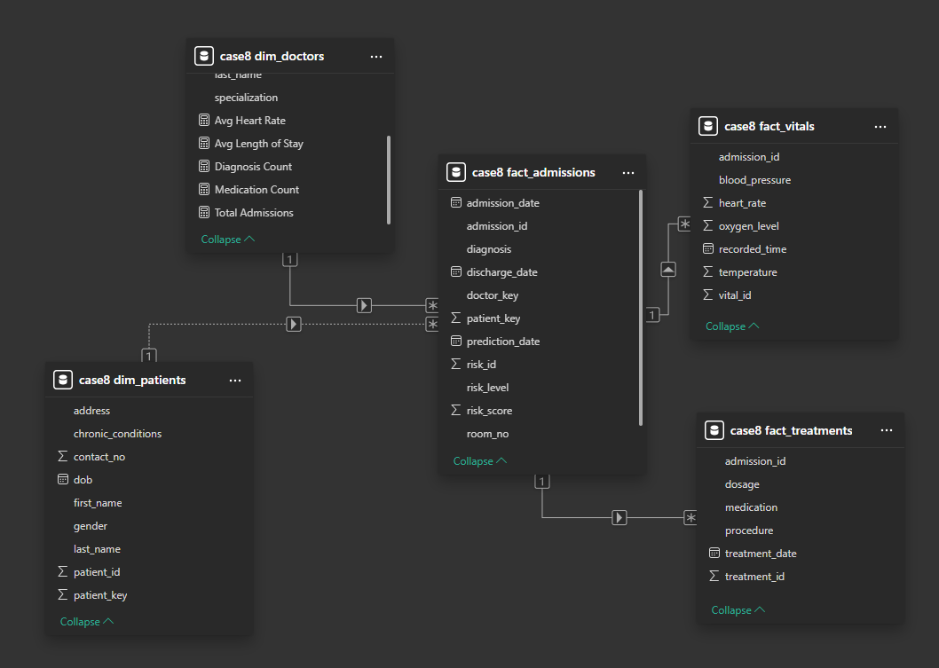

## 6. PowerBI Report

All Data is self generated so creating report is unnessesary

## 7. Example SQL Queries for Analytics

Once the data is in MySQL, I can run queries such as:

### Admissions by Day

SELECT   
 DATE(admission_date) AS admission_day,  
 COUNT(*) AS total_admissions  
FROM fact_admissions  
GROUP BY DATE(admission_date)  
ORDER BY admission_day;

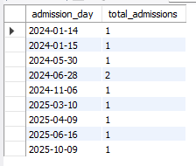

### Average Risk Score by Diagnosis

SELECT   
 diagnosis,  
 AVG(risk_score) AS avg_risk  
FROM fact_admissions  
WHERE risk_score IS NOT NULL  
GROUP BY diagnosis  
ORDER BY avg_risk DESC;

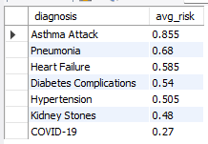

### Most Common Diagnoses

SELECT  
 diagnosis,  
 COUNT(*) AS diagnosis_count  
FROM fact_admissions  
GROUP BY diagnosis  
ORDER BY diagnosis_count DESC  
LIMIT 5;

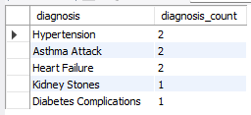

### Average Length of Stay by Diagnosis

SELECT  
 diagnosis,  
 AVG(DATEDIFF(discharge_date, admission_date)) AS avg_length_of_stay  
FROM fact_admissions  
WHERE discharge_date IS NOT NULL  
GROUP BY diagnosis  
ORDER BY avg_length_of_stay DESC;

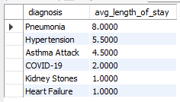

### Most Frequently Prescribed Medications

SELECT  
 medication,  
 COUNT(*) AS usage_count  
FROM fact_treatments  
GROUP BY medication  
ORDER BY usage_count DESC  
LIMIT 5;

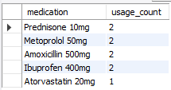

### Average Heart Rate by Diagnosis

SELECT  
 fa.diagnosis,  
 AVG(fv.heart_rate) AS avg_heart_rate  
FROM fact_admissions AS fa  
JOIN fact_vitals AS fv  
 ON fa.admission_id = fv.admission_id  
GROUP BY fa.diagnosis  
ORDER BY avg_heart_rate DESC;

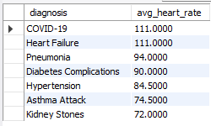

# Conclusion

No conclusion because data is all self generated.